A000-EUR-France-La Tene-Spiral Fibula-Iron-Iron Age-c 900 CE

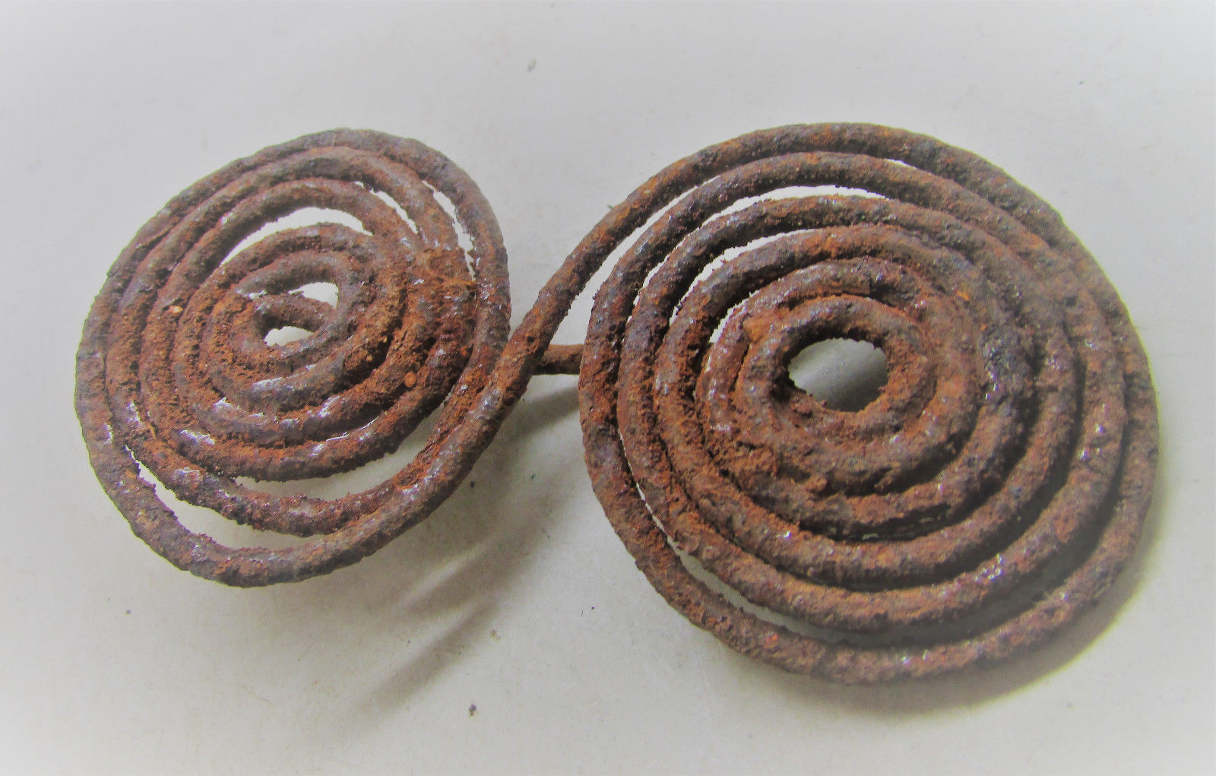

AP: 3

Michael Davies

2 Hanover court

Didcot

Oxfordshire

ox11 8nu

United Kingdom